Welcome to tutorial one!

This is a LAG tutorial aka learn as you go…

Visual Studio

GitHub

GitBash

NodeJs – npm

NuxtJs

Vue2

1. Visual Studio Code:

Tutorial: <https://www.toolsqa.com/blogs/install-visual-studio-code/>

Download: <https://code.visualstudio.com/download>

a) Windows x64: <https://code.visualstudio.com/docs/?dv=win>

b) MacOS: <https://code.visualstudio.com/docs/?dv=osx>

1. GitHub: create an account:

Tutorial: <https://git-scm.com/book/en/v2/GitHub-Account-Setup-and-Configuration>

Website: <https://github.com/join>

1. GitBash:

Tutorial: <https://phoenixnap.com/kb/how-to-install-git-windows>

Download: <https://git-scm.com/downloads>

1. Windows x64: <https://git-scm.com/download/win>
2. MacOS: <https://git-scm.com/download/mac>

1. NodeJs:

Tutorial: <https://www.w3schools.com/nodejs/default.asp>

<https://www.tutorialsteacher.com/nodejs/nodejs-console-repl>

Download: <https://nodejs.org/en/download/>

1. Windows x64: <https://nodejs.org/dist/v14.17.0/node-v14.17.0-x86.msi>
2. MacOS: <https://nodejs.org/dist/v14.17.0/node-v14.17.0.pkg>
3. NuxtJs:

Tutorial: <https://nuxtjs.org/video-courses/>

Documentation: <https://nuxtjs.org/docs/2.x/get-started/installation/>

1. Vue2:

Tutorial: <https://www.youtube.com/watch?v=ltzlhAxJr74>

Documentation: <https://vuejs.org/v2/guide/>

Free code: <https://vuetifyjs.com/en/getting-started/installation/#vue-cli-install>

Visual Studio Code Cheats: <https://go.microsoft.com/fwlink/?linkid=832143>

<https://go.microsoft.com/fwlink/?linkid=832144>

<https://go.microsoft.com/fwlink/?linkid=832145>

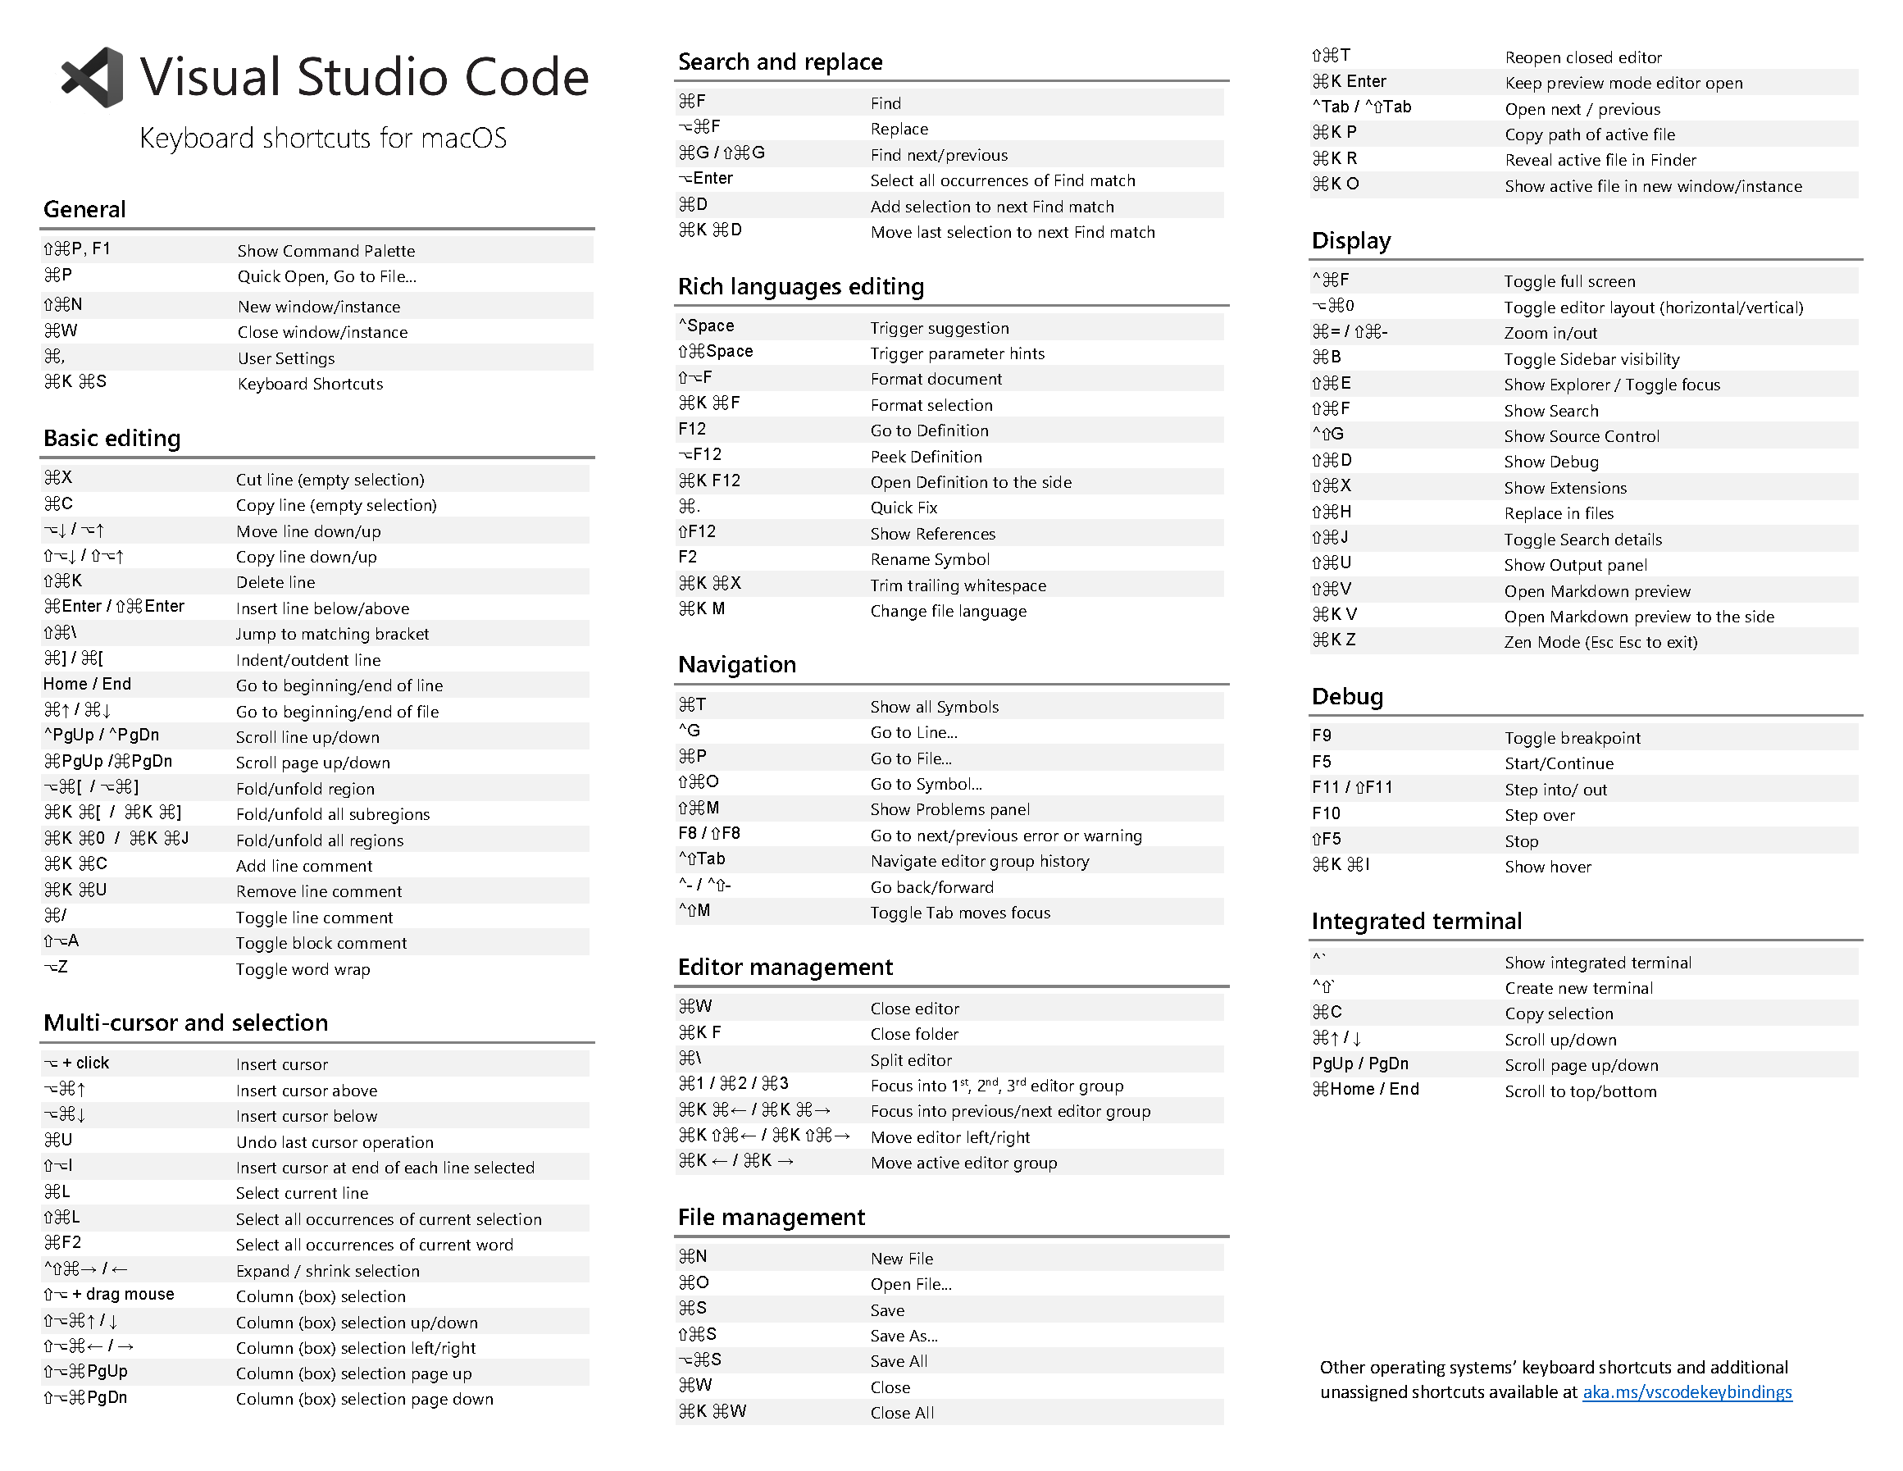

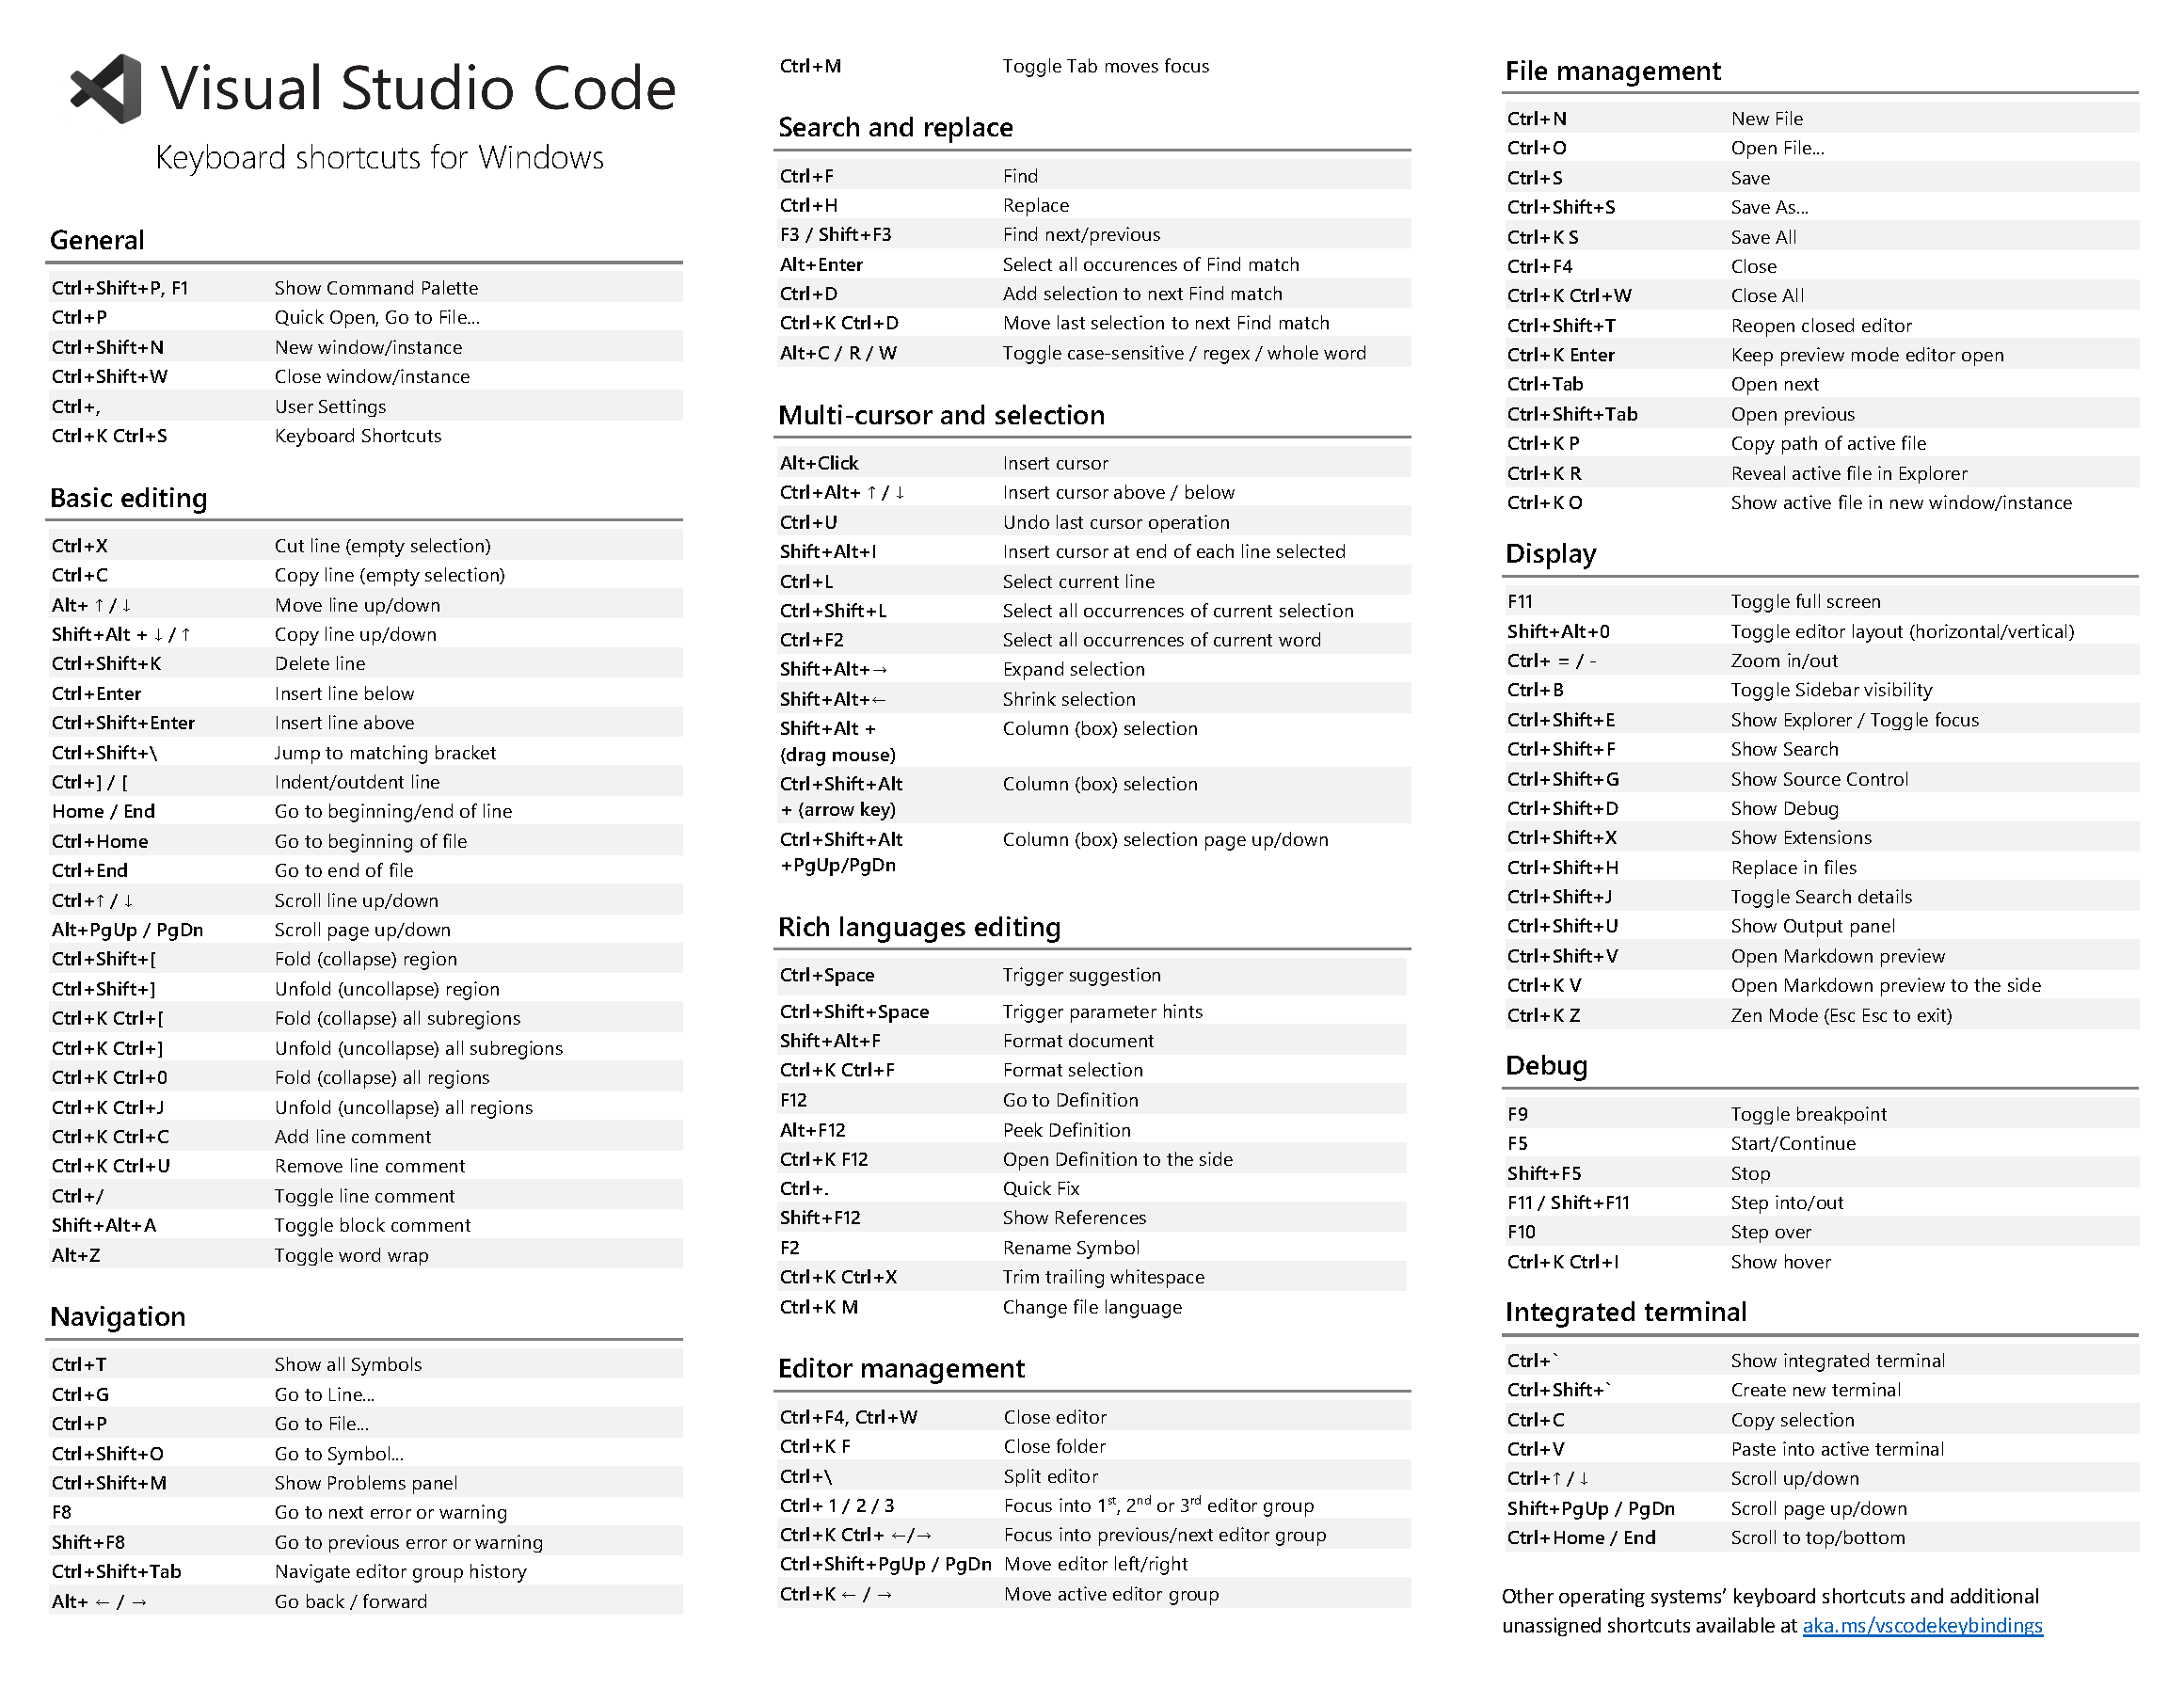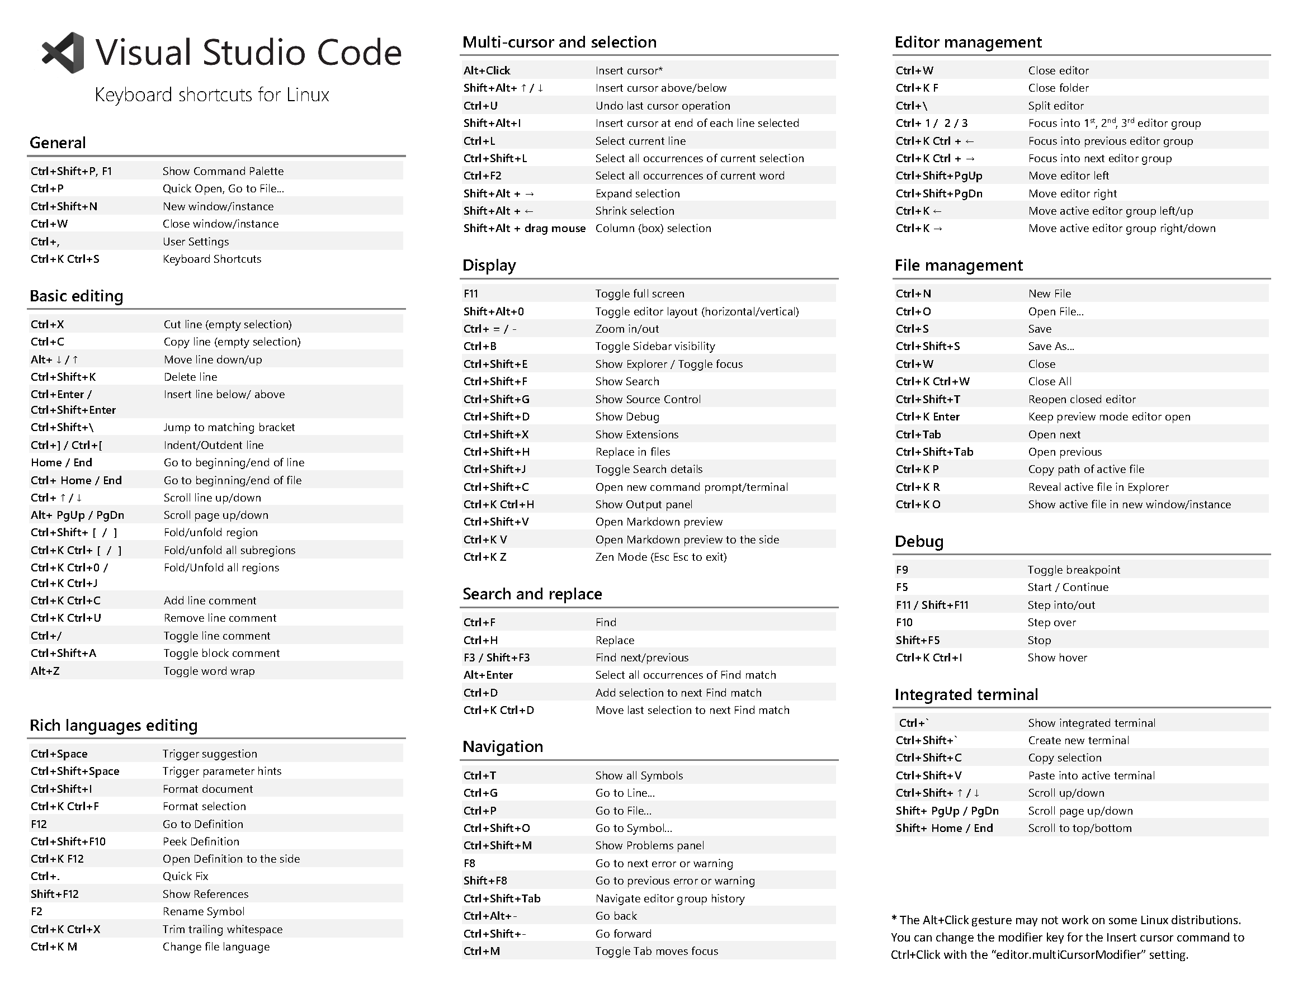

GitHub Cheats: <https://i.redd.it/8341g68g1v7y.png>

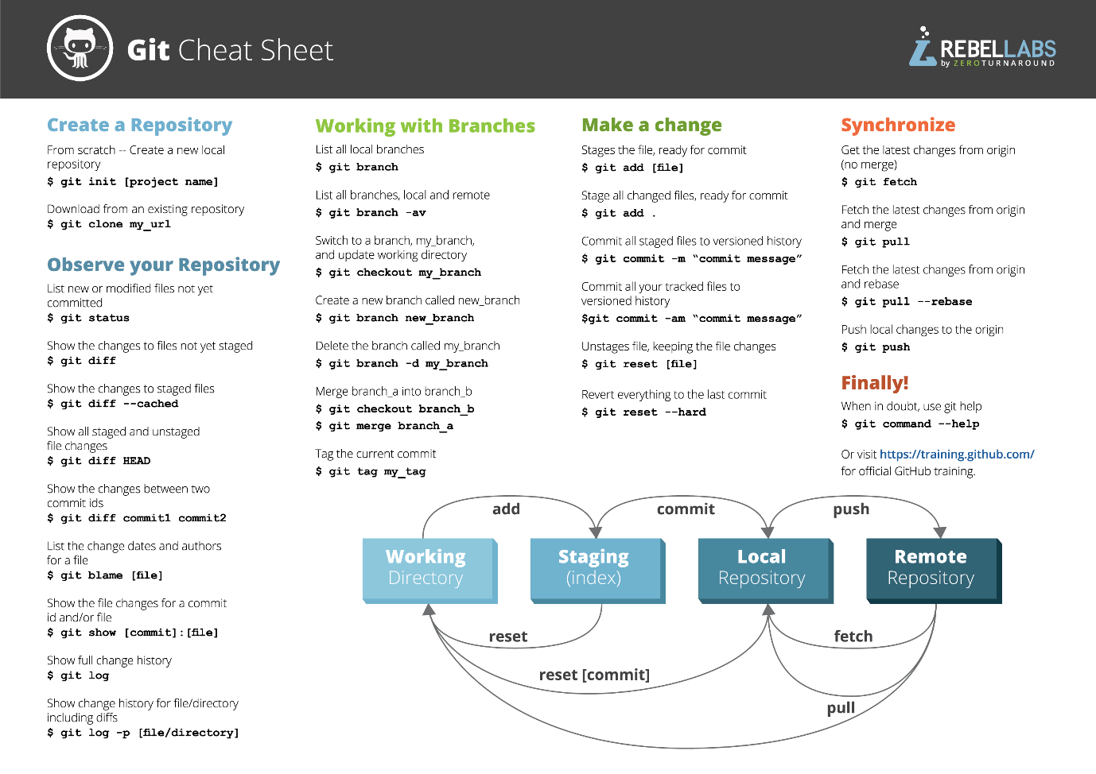

GitBash Cheats: <https://www.git-tower.com/blog/command-line-cheat-sheet/>

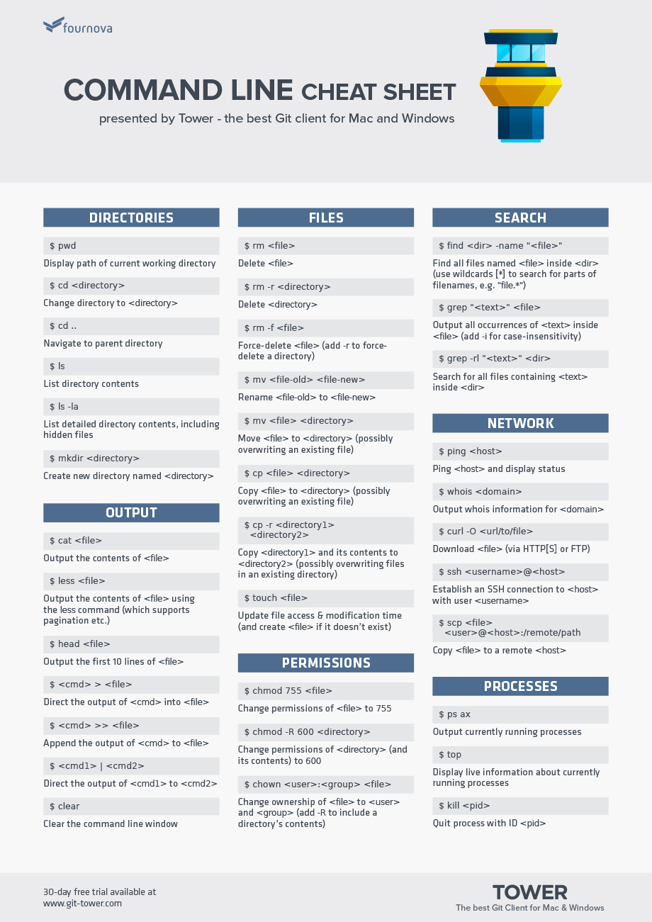

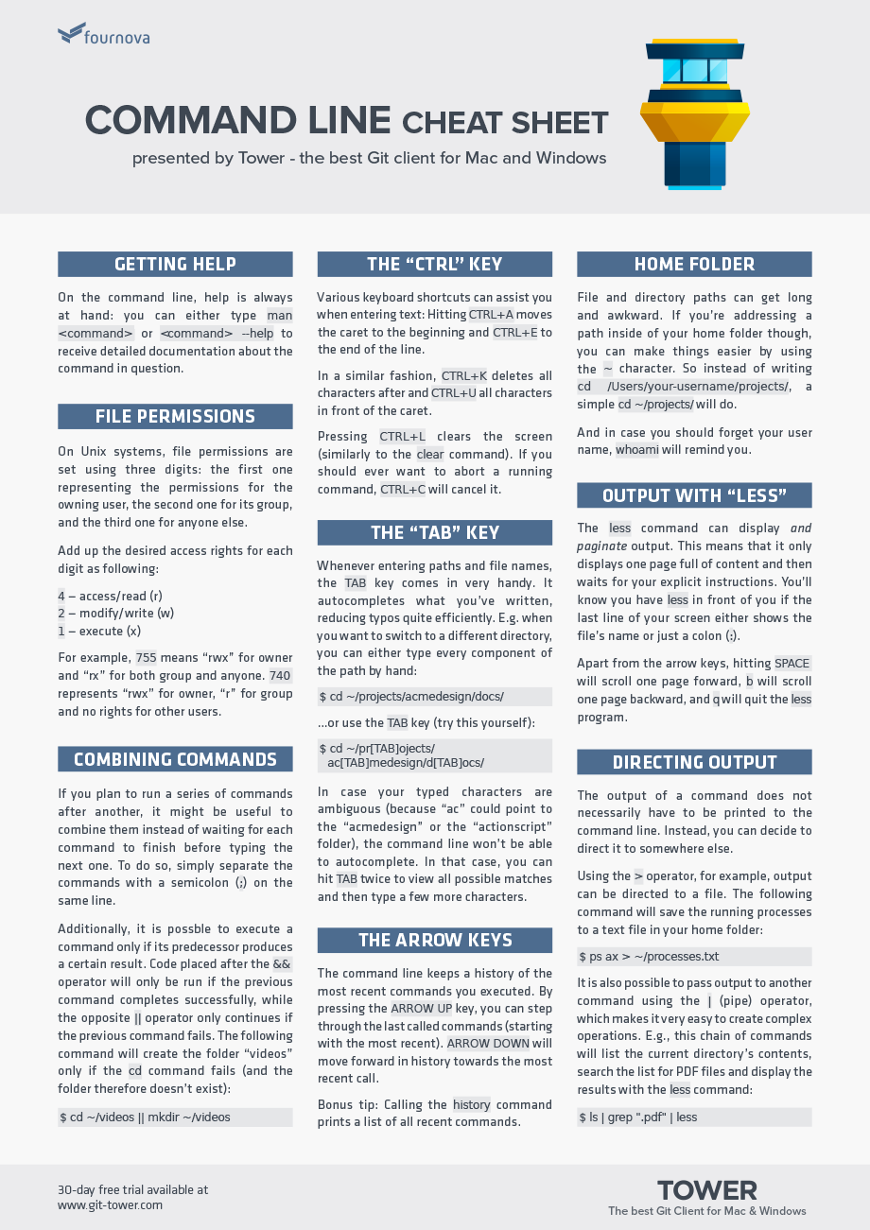

NodeJs Cheats: <https://downloads.gosquared.com/help_sheets/11/Node%20Help%20Sheet.pdf> 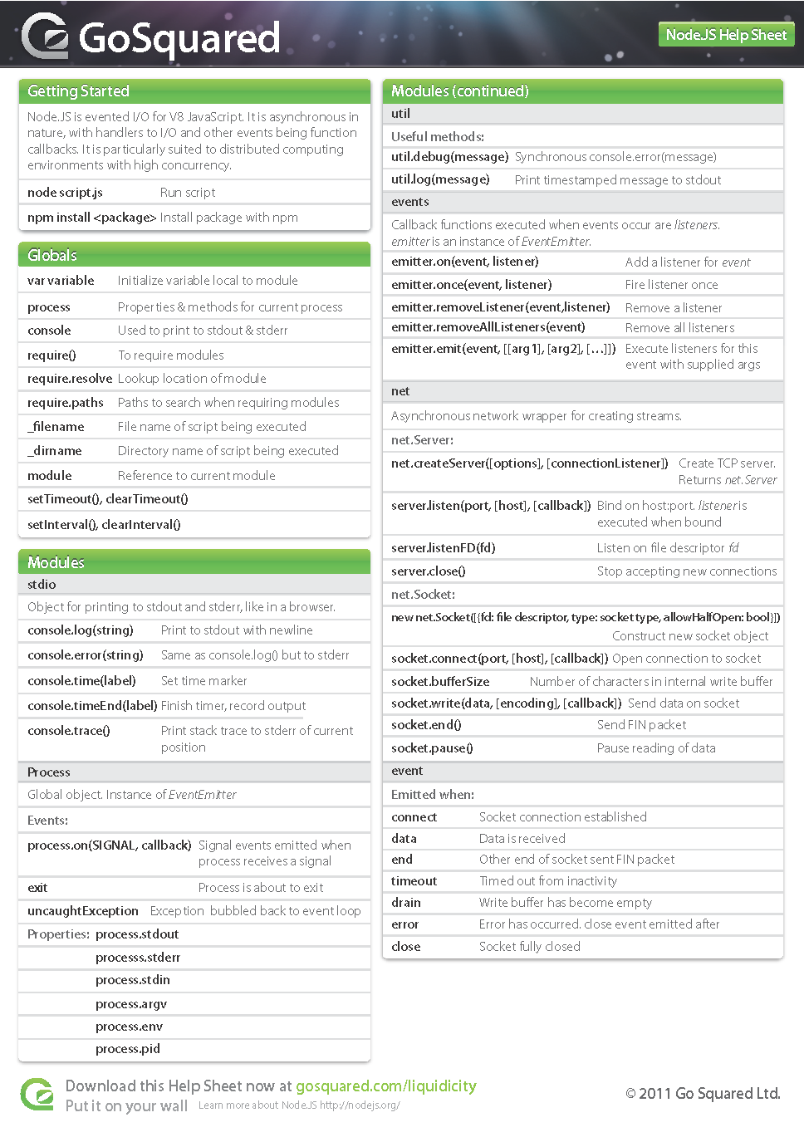

NuxtJs cheats: <https://www.vuemastery.com/vue-cheat-sheet/> 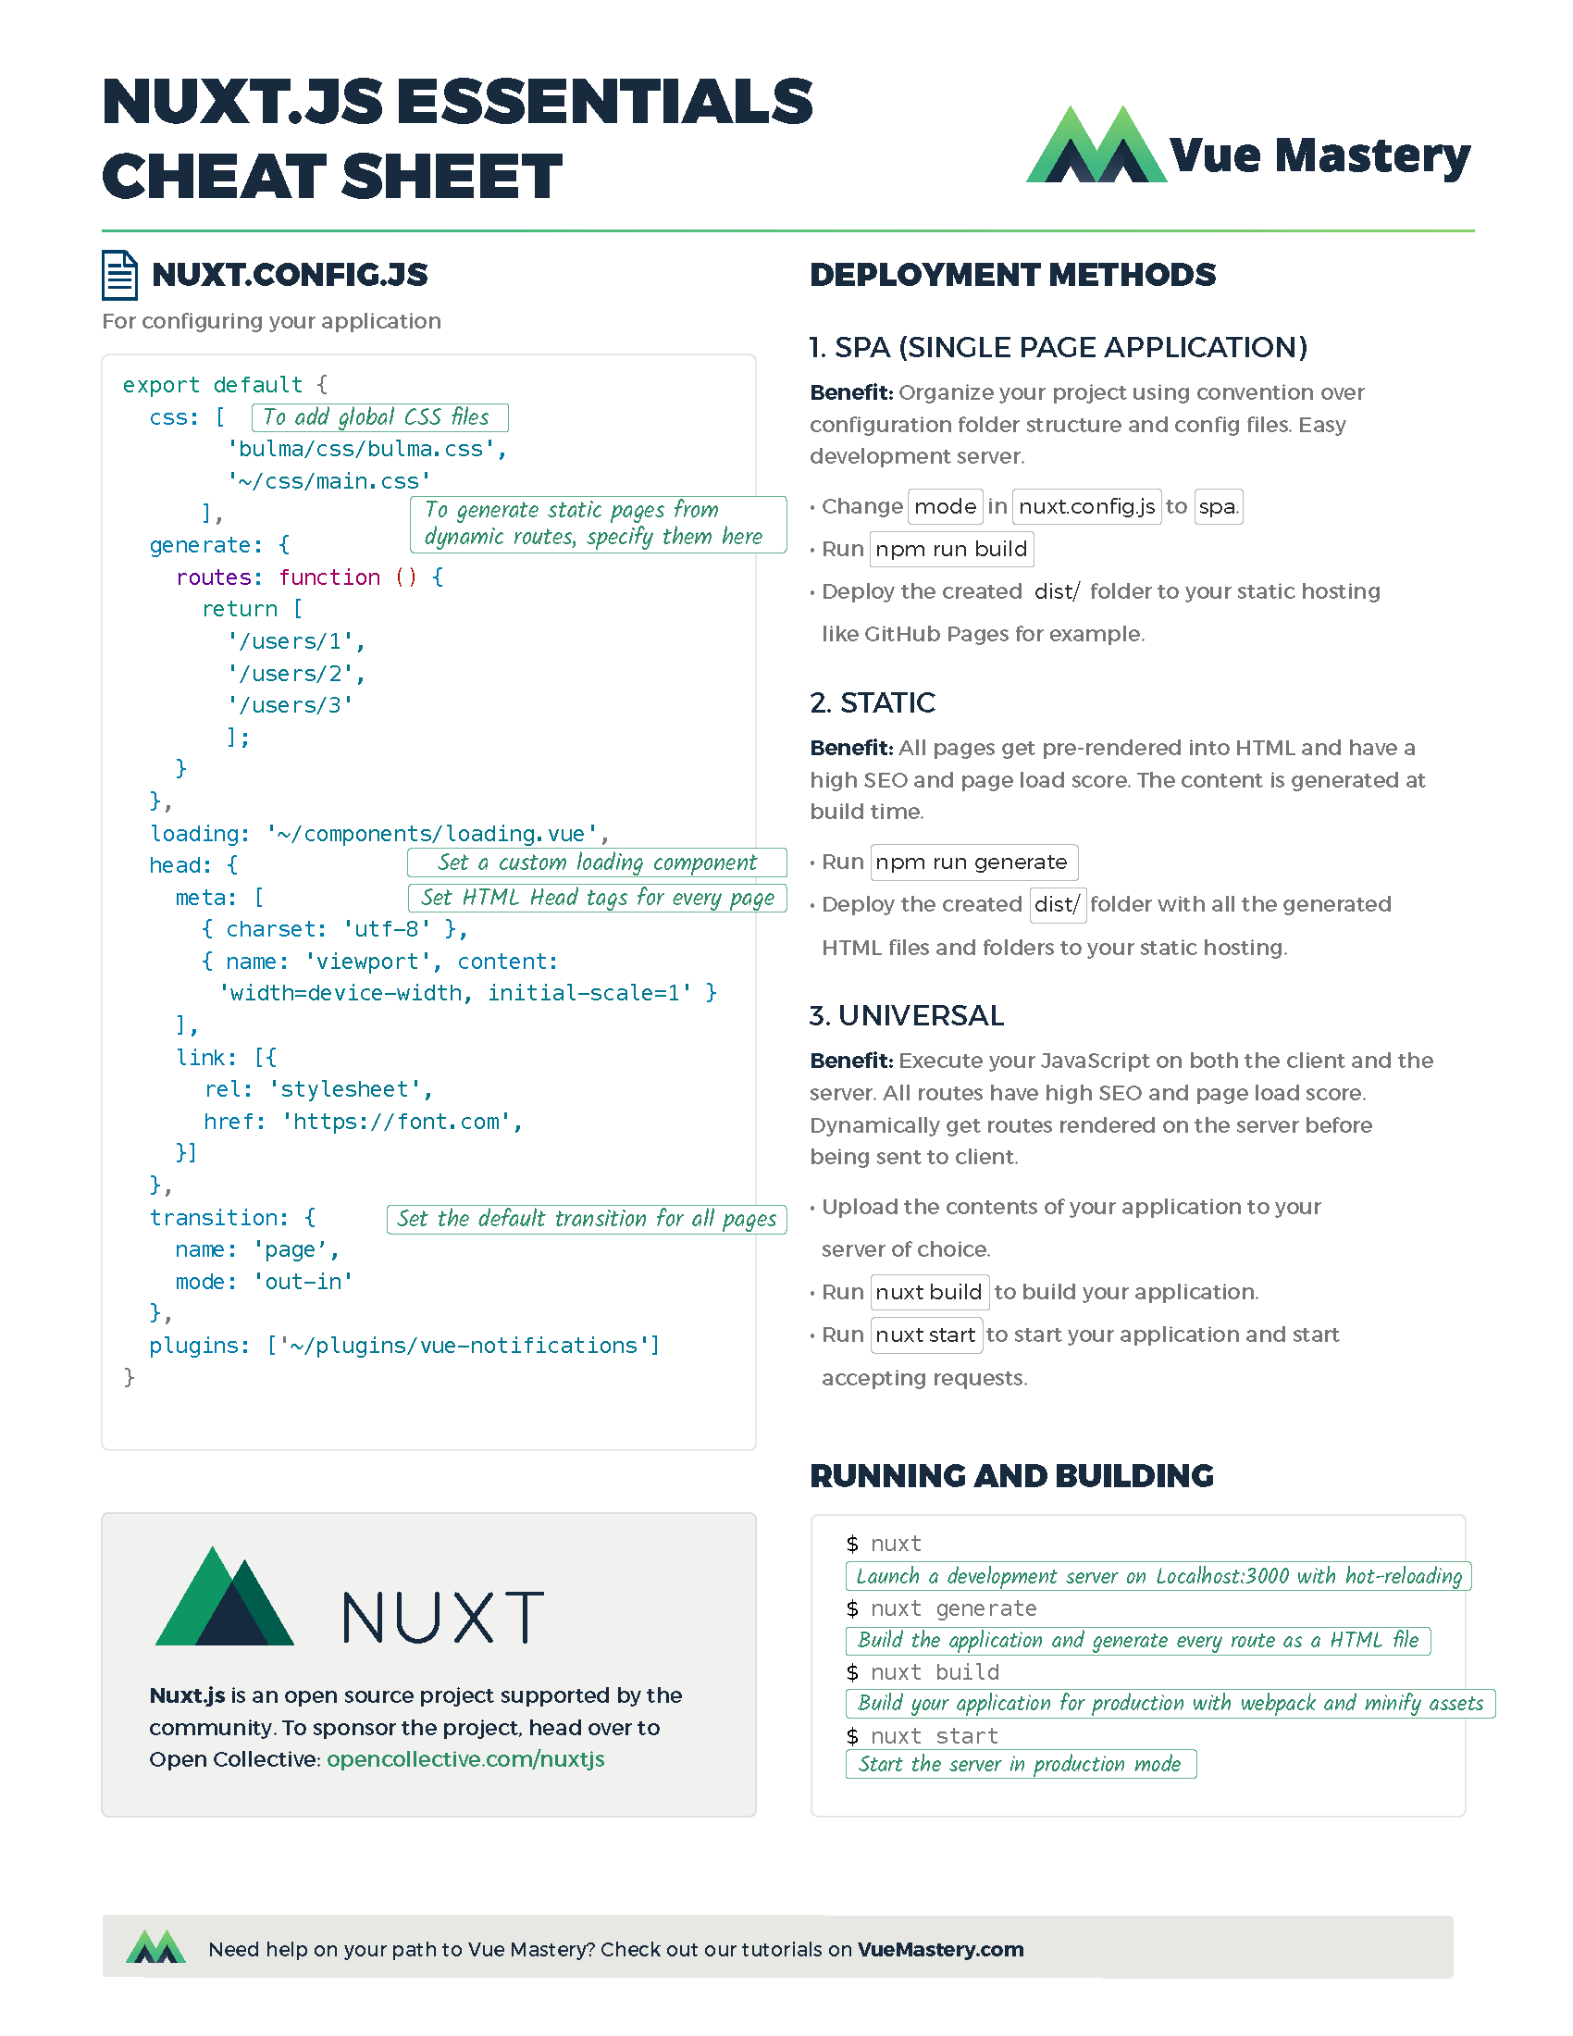

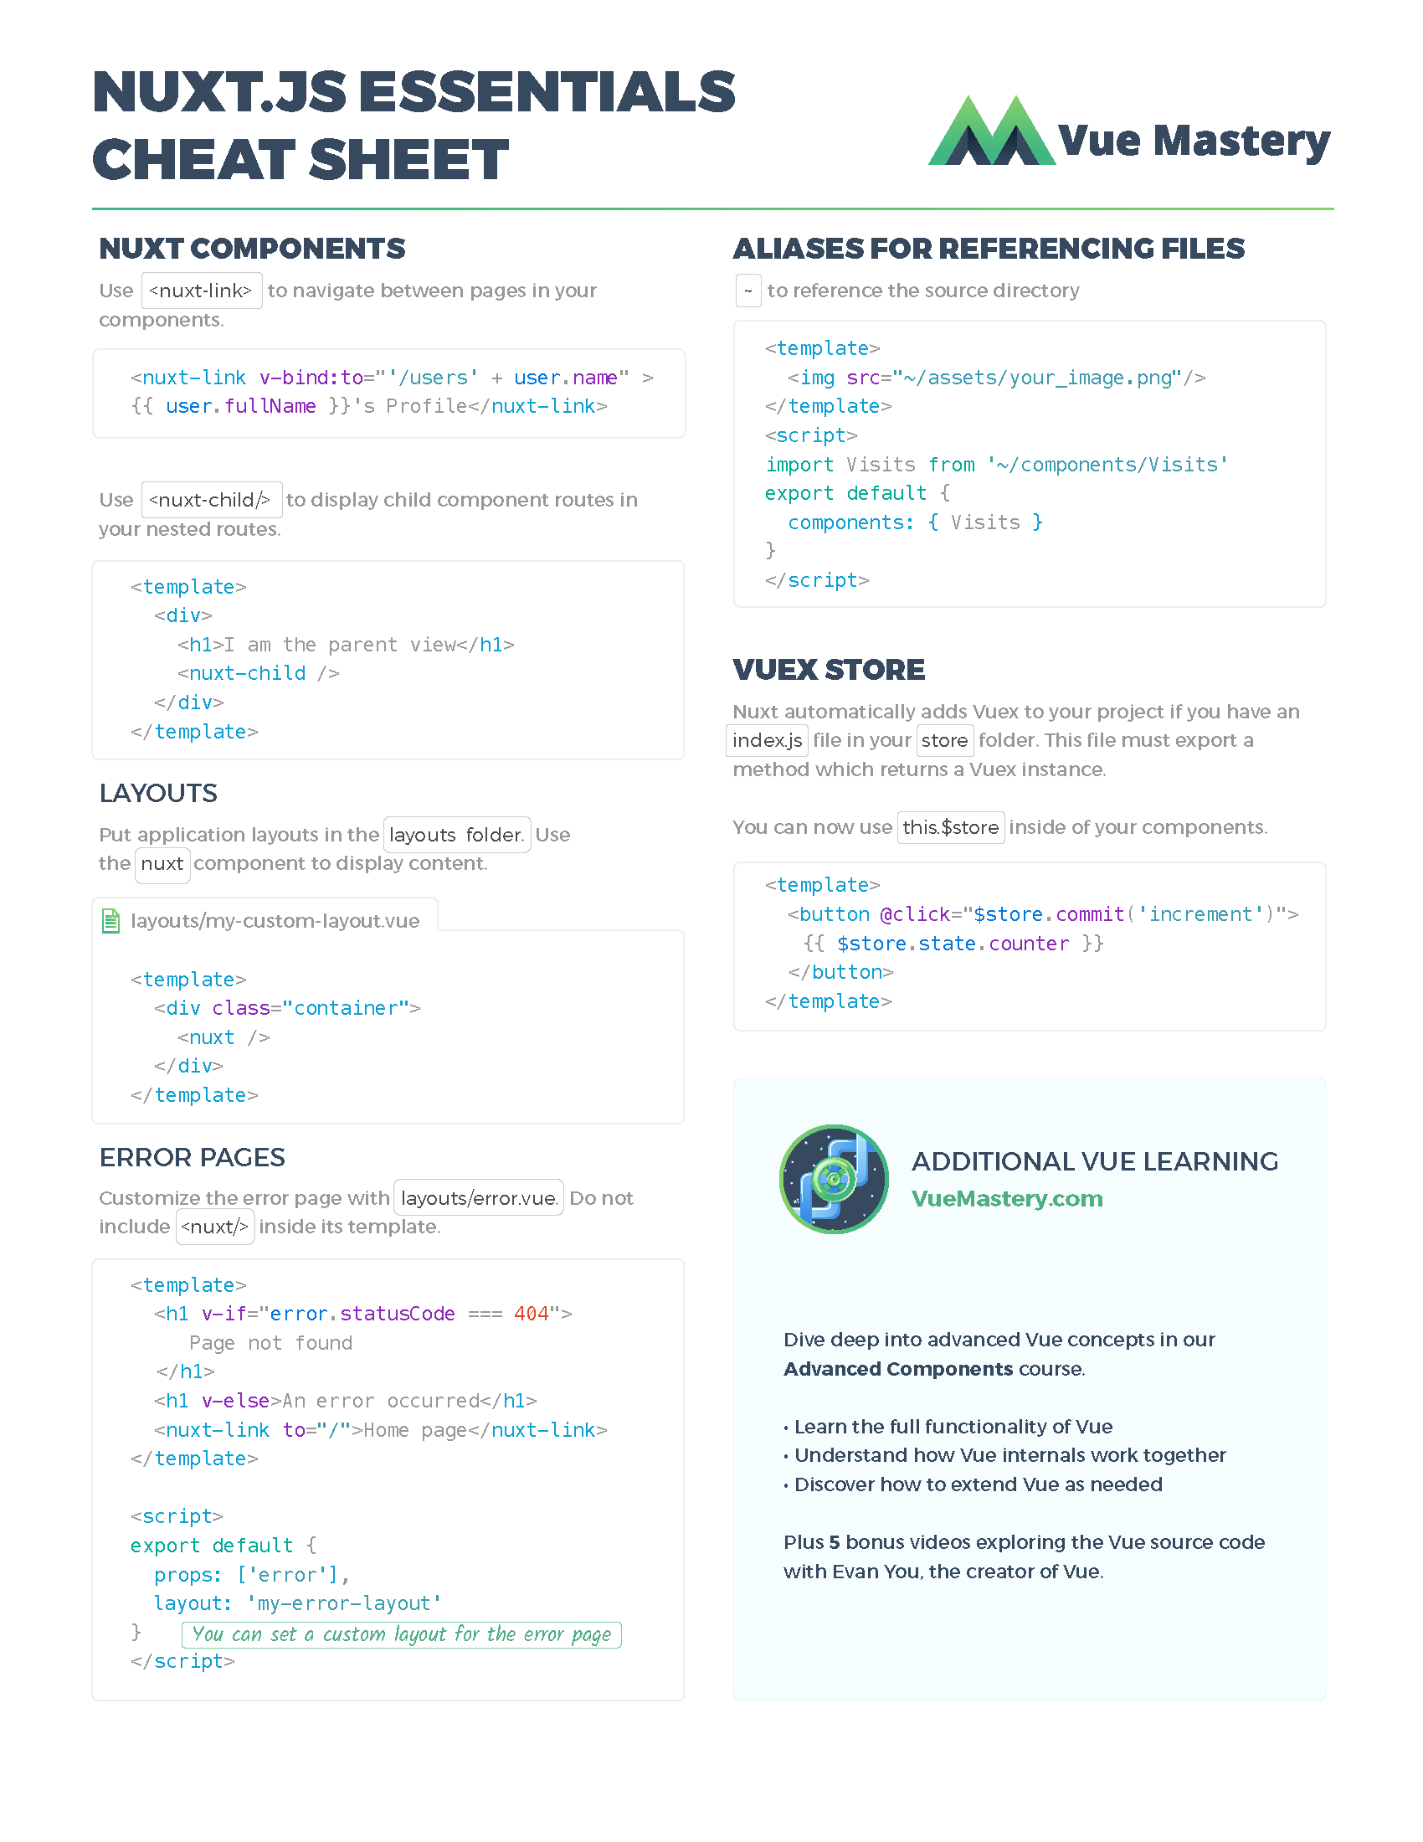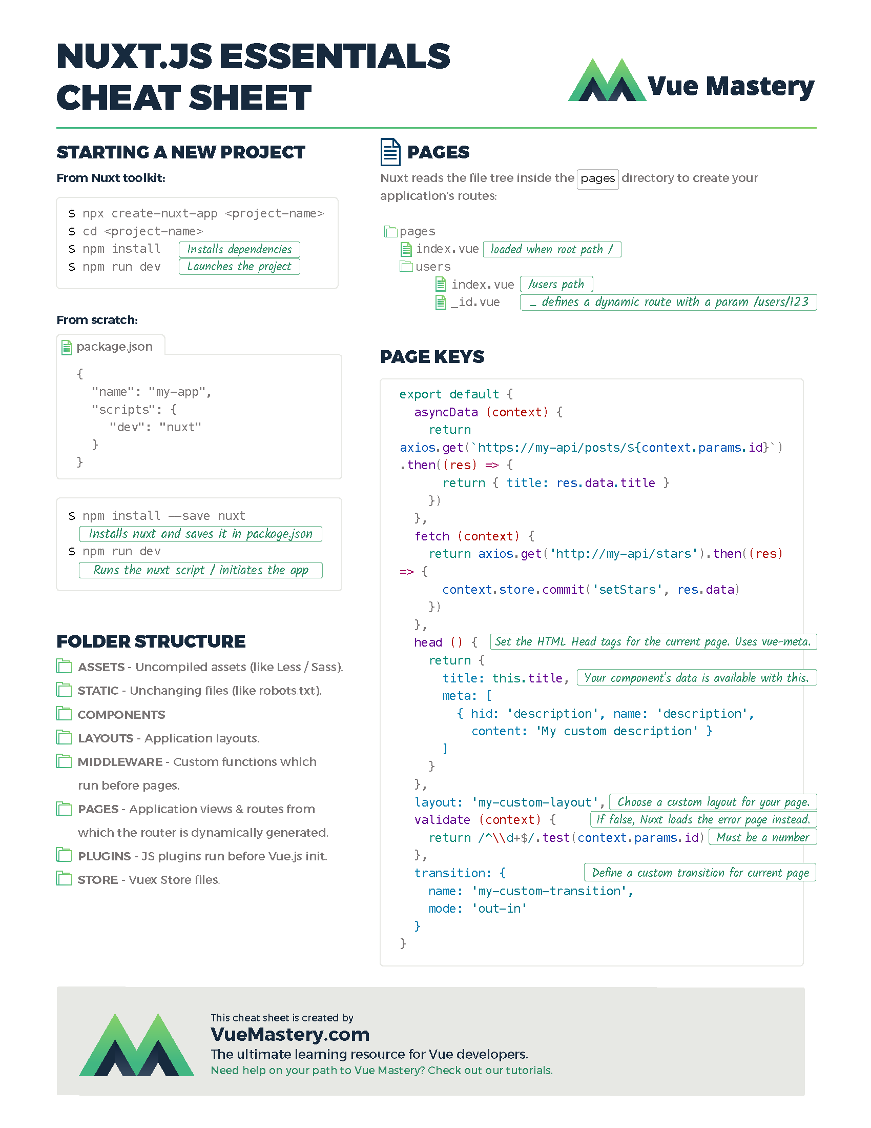

VueJs Cheats: <https://www.vuemastery.com/pdf/Vue-Essentials-Cheat-Sheet.pdf>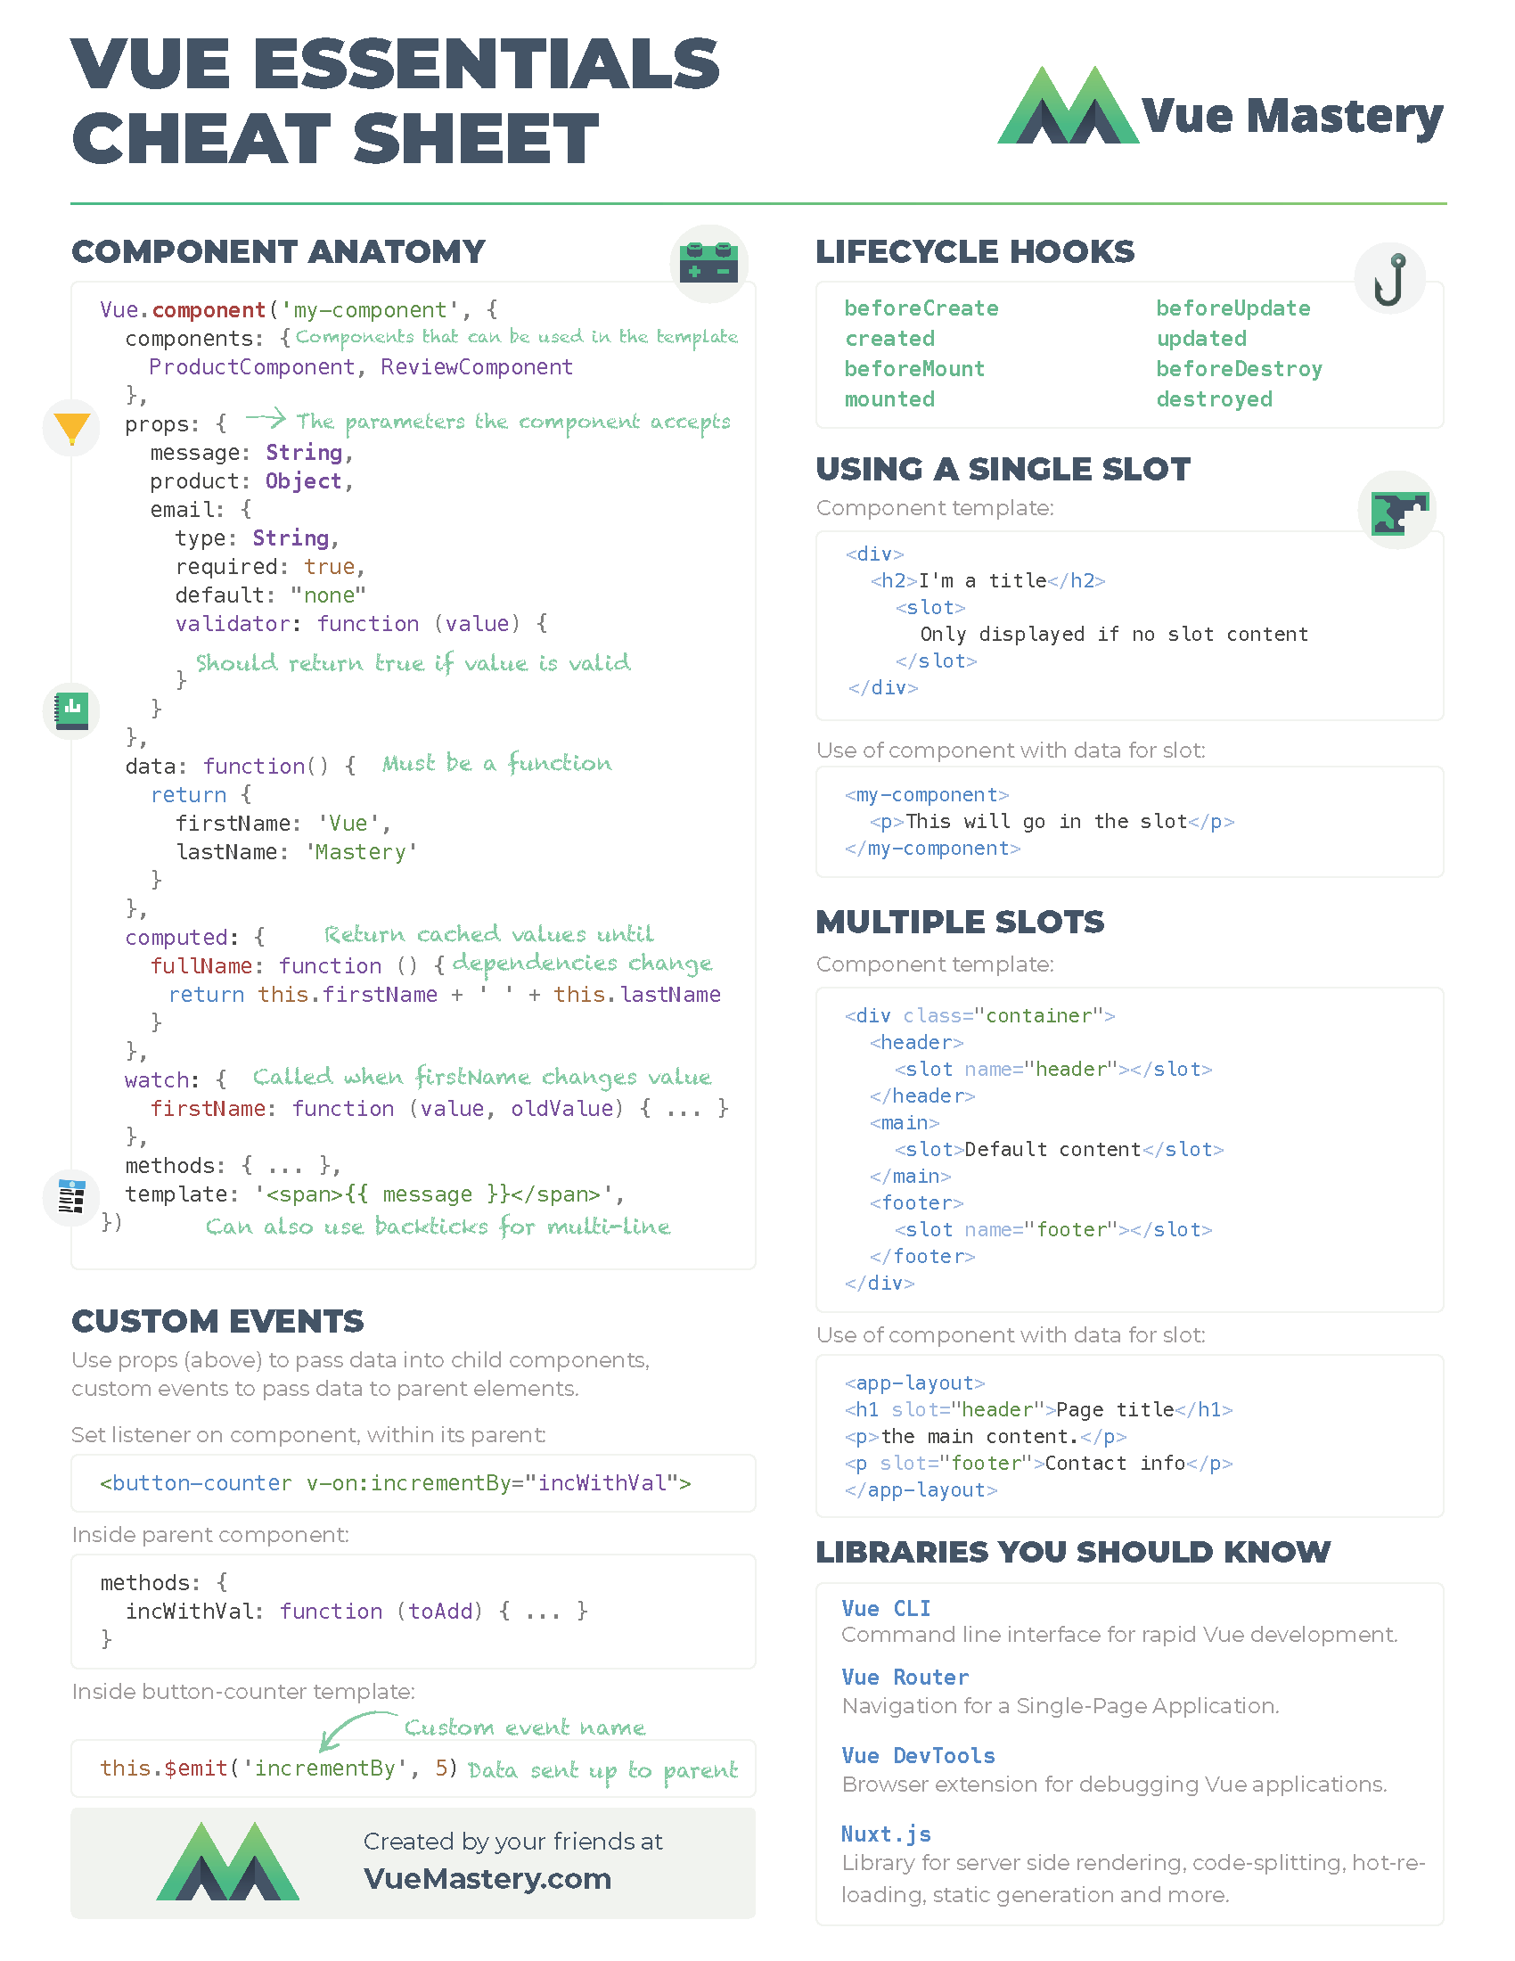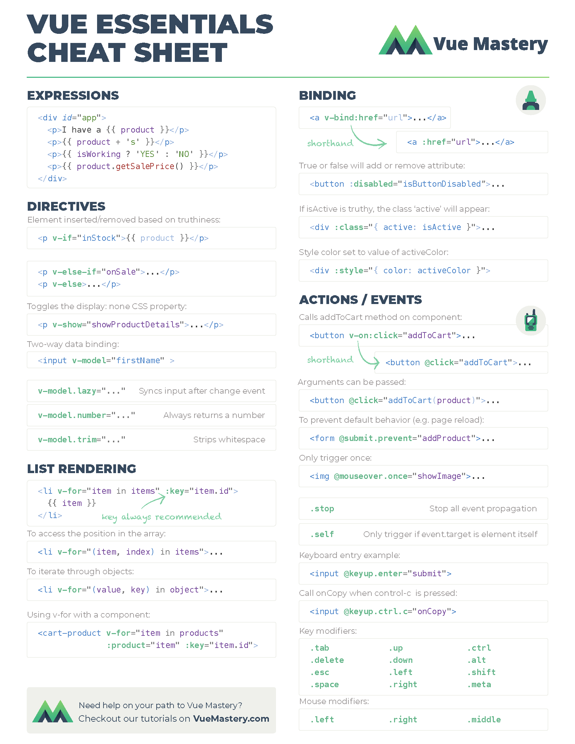

Updated on 31/5/2021 AlbertoPP